INDEX

|  |  |  |  |  |  |  |
| --- | --- | --- | --- | --- | --- | --- |
| S.NO | DATE | NAME OF THE EXPERIMENT | PAGE | TEXT BOOK | MARKS | SIGNATURE OF THE STAFF |
| 1. |  | ROLE OF SOFT SKILLS FOR A PROFESSIONAL CAREER | 2-7 |  |  |  |
| 2. |  | HOW TO GET SOFT SKILLS | 9-17 |  |  |  |
| 3. |  | TOP INTER-PERSONAL SKILLS THAT EMPLOYER’S VALUE | 19-29 |  |  |  |
| 4. |  | DEBATE | 31-37 |  |  |  |
| 5. |  | GROUP DISCUSSION | 38-43 |  |  |  |
| 6. |  | REVIEWING A BOOK/FILM | 45-53 |  |  |  |
| 7. |  | CONFLICT RESOLUTION SKILLS | 55-58 |  |  |  |
| 8. |  | ACTIVE LISTENING SKILLS | 60-66 |  |  |  |
| 9. |  | INTERVIEW SKILLS-HOW TO ANSWER”TELL ME ABOUT YOURSELF” | 68-76 |  |  |  |
| 10 |  | INTERVIEW SKILLS-HOW TO CONVEY-“ WHAT YOU’RE PASSIONATE ABOUT” | 78-87 |  |  |  |

|  |  |  |  |  |  |  |
| --- | --- | --- | --- | --- | --- | --- |
| 11 |  | INTERVIEW SKILLS-HOW TO ANSWER”WHY YOU ARE THE BEST PERSON FOR THE JOB” | 88-93 |  |  |  |

ACTIVITY 1:ROLE OF SOFT SKILLS FOR A PROFESSIONAL CAREER

Objectives:

1.To explain the basic concepts of soft skills to students

2.To recognize the importance of soft skills in a profession

3.To apply the knowledge of soft skills gained for their personal growth in a professional field.

Pre-Lab questions:

1.What is the most crucial thing that the recruiters seek in an employee?

2.Are soft skills necessary in a professional career?what role do they play?

------------------------------------------------------------------------------------------------------------------------------------------------------------------------------------------------------------------------------------------------------------------------------------------------------------

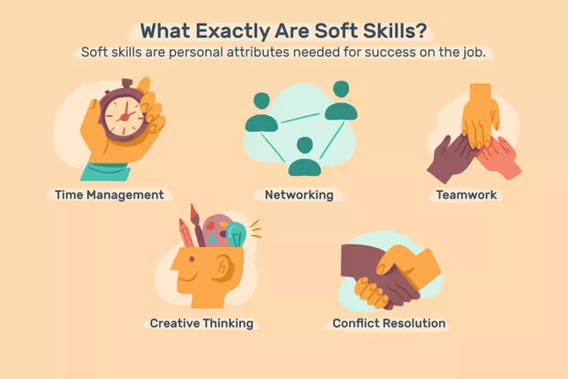

What are soft skills

Definition of soft skills

Soft skills are non-technical skills that relate to how you work. They include how you interact with colleagues, how you solve problems, and how you manage your work.

Lets learn, what soft skills are, types and examples of soft skills, and ways to develop soft skills.

What Are Soft Skills?

Soft skills relate to how you work. Soft skills include interpersonal (people) skills, communication skills, listening skills, time management, and empathy, among others. They are among the top skills employers seek in the candidates they hire, because soft skills are important for just about every job.

Hiring managers typically look for job candidates with soft skills because they make someone more successful in the workplace.1 Someone can be excellent with technical, job-specific skills, but if they can't manage their time or work within a team, they may not be successful in the workplace.

Alternate names: Interpersonal skills, essential skills, noncognitive skills

How Soft Skills Work

Soft skills are also important to the success of most employers. After all, nearly every job requires employees to engage with others in some way.

Another reason hiring managers and employers look for applicants with soft skills is that soft skills are transferable skills that can be used regardless of the person's job. This makes job candidates with soft skills very adaptable and flexible employees.

Soft skills are particularly important in customer-based jobs. These employees are in direct contact with customers. It takes several soft skills to be able to listen to a customer and provide that customer with helpful and polite service.

Even if you're not in a client-facing role, you need to be able to get along with coworkers, managers, vendors, and other people you interact with at work.

Types of Soft Skills

Soft skills include the personal attributes, personality traits, and communication abilities needed for success on the job. Soft skills characterize how a person interacts in his or her relationships with others.

Soft skills include:

Adaptability

Communication

Compromise

Creative thinking

Dependability

Leadership

Listening

Work ethic

Teamwork

Positivity

Time management

Motivation

Problem-solving

Critical thinking

Conflict resolution

Negotiation

Post Lab questions:

Define the following terms:

(a)Communication

------------------------------------------------------------------------------------------------------------------------------------------------------------------------------------------------------------------------------------------------------------------------------------------------------------------------------------------------------------------------------------------------------------------------------------------------------------------------------------------------------------------------------------------------------------------------

(b)Leadership

------------------------------------------------------------------------------------------------------------------------------------------------------------------------------------------------------------------------------------------------------------------------------------------------------------------------------------------------------------------------------------------------------------------------------------------------------------------------------------------------------------------------------------------------------------------------

(c)Motivation

------------------------------------------------------------------------------------------------------------------------------------------------------------------------------------------------------------------------------------------------------------------------------------------------------------------------------------------------------------------------------------------------------------------------------------------------------------------------------------------------------------------------------------------------------------------------

(d)Problem solving

-----------------------------------------------------------------------------------------------------------------------------------------------------------------------------------------------------------------------------------------------------------------------------------------------------------------------------------------------------------------------------------------------------------------------------------------------------------------------------------------------------------------------------------------------------------------------

(e)Critical thinking

-----------------------------------------------------------------------------------------------------------------------------------------------------------------------------------------------------------------------------------------------------------------------------------------------------------------------------------------------------------------------------------------------------------------------------------------------------------------------------------------------------------------------------------------------------------------------

(f)Positivity

-----------------------------------------------------------------------------------------------------------------------------------------------------------------------------------------------------------------------------------------------------------------------------------------------------------------------------------------------------------------------------------------------------------------------------------------------------------------------------------------------------------------------------------------------------------------------

(g)Work ethic

------------------------------------------------------------------------------------------------------------------------------------------------------------------------------------------------------------------------------------------------------------------------------------------------------------------------------------------------------------------------------------------------------------------------------------------------------------------------------------------------------------------------------------------------------------------------

Learning Outcomes:

After the completion of this activity students will be able to

1.Define the need to learn and impliment soft skills for a good career.

2.Identify the various skills needed for their personal growth in a profession.

3.Learn why soft skills are so important to maintain a good stability to their career.

|  |  |  |  |  |  |  |
| --- | --- | --- | --- | --- | --- | --- |
| Date of submission |  |  |  |  |  |  |
| Name of the Evaluator |  |  |  |  |  |  |
| Marks  Awarded | Pre lab questions  (2M) | Format and structure(2M) | Content  (2M) | Language and Tone  (2M) | Post Lab Questions  (2M) | Total  (10M) |
|  |  |  |  |  |  |
| Remarks |  |  |  |  |  |  |
| Signature of the Evaluator with Date |  |  |  |  |  |  |

Grading:

ACTIVITY 2:How to Get Soft Skills

Objectivies:

1.To make the students learn how to aquire soft skills.

2.To help the students learn the difference between hard skills and soft skills.

3.To make them highlight the soft skills.

Pre-Lab questions:

1.What areSoft skills?How to aquire them?

Unlike hard skills that are learned, soft skills are similar to emotions or insights that allow people to “read” others. These are much harder to learn, at least in a traditional classroom. They are also much harder to measure and evaluate.

That said, some job training programs do cover soft skills. They may discuss soft skills so job seekers know what they are and the importance of highlighting them on their resume.3 There are also free online courses that can help you improve your soft skills.

If you've been working for a while, chances are you've already developed some soft skills. For example, if you've worked in retail, you've worked in a team environment. If you've helped unhappy customers find a resolution, you've used conflict resolution and problem-solving skills.

If you're new to work, think of other activities you've done, either through school or on a volunteer basis. Chances are you've had to communicate, adapt to changes, and solve problems.

You can also reflect on soft skills you need to develop. For example, instead of just discussing problems with your manager, suggest solutions to those problems. If you see a colleague struggling, offer to pitch in. If there's a process that could improve your workplace, suggest it.

Employers typically don't directly ask if you have soft skills. Instead, they present situations and ask what you would do to assess whether you have soft skills.4

How to Highlight Your Soft Skills

When you're applying for a new job, highlight your soft skills as well as your job-specific ones. First, make a list of the soft skills you have that are relevant to the job you want. Compare your list of soft skills with the job listing.

Include some of these soft skills in your resume. You can add them to a skills section.

You can also mention these soft skills in your cover letter. Pick one or two soft skills you have that appear to be the most important for the job you’d like. In your cover letter, provide evidence that shows you have those particular skills.

Finally, you can highlight these soft skills in your interviews. You can demonstrate your soft skills during the interview by being friendly and approachable. If you pay close attention while the interviewer is talking, you will show your listening skills.

Key Takeaways

Soft skills are non-technical skills that impact your performance in the workplace.

You likely already have soft skills from your school and work experience.

You can also develop soft skills at work, school, volunteer activities, and by participating in training programs and classes.

Include your soft skills in your resume and cover letter.

Demonstrate your soft skills during job interviews

.**Hard Skills vs. Soft Skills: What's the Difference**?

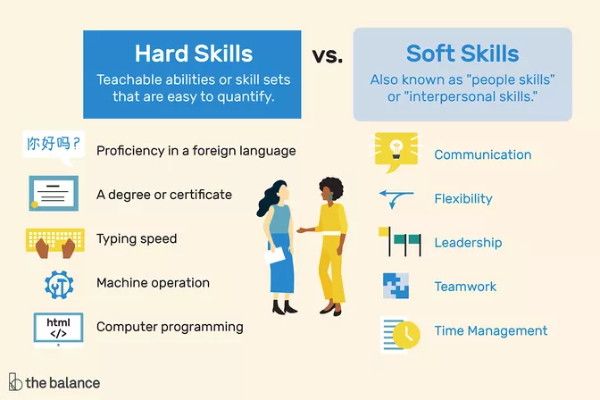

During the job application and interview process, employers look for applicants with hard skills and soft skills. Successful candidates will make sure to put both skill sets on display. In order to do so effectively, it helps to understand the difference between these two types of skills.

Review the differences between hard and soft skills, what employers look for, how to highlight your skills, and examples of each type of skill.

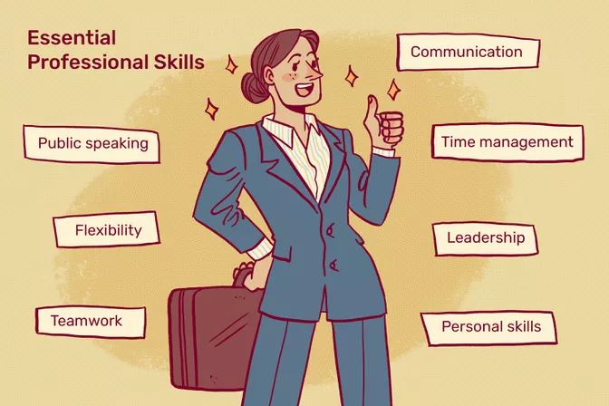

What Are Hard Skills?

Hard skills are teachable abilities or skill sets that are easy to quantify. Typically, you'll learn hard skills in the classroom, through books or other training materials, or on the job.

1.Hard skills are easy for an employer or recruiter to recognize. Hard skills include:Proficiency in a foreign language

A degree or certificate

Typing speed

Machine operation

Computer programming

What Are Soft Skills?

Soft skills, on the other hand, are subjective skills that are much harder to quantify. Also known as "people skills" or "interpersonal skills," soft skills relate to the way you relate to and interact with other people.

2 Soft skills include:

Communication

Flexibility

Leadership

Motivation

Patience

Persuasion

Problem solving abilities

Teamwork

Time management

Work ethic

Unlike hard skills, it's hard to point to specific evidence that you possess a soft skill. If an employer is looking for someone who knows a programming language, you can share your grade in a class or point to a program you created using the language. But how can you show that you have a work ethic or any other soft skill?

Make note of your soft skills and point out some concrete instances where you've used them.

Just saying you have the skill isn't very meaningful. Instead, your best bet is to demonstrate that you possess this quality by sharing examples of times when you used it.Top Skills Employers Look For

While certain hard skills are necessary for any position, employers increasingly look for job applicants with certain soft skills. That's because it's generally easier for an employer to train a new employee in a hard skill (such as how to use a certain computer program) than to train an employee in a soft skill (such as patience).

Analytical skills, communication skills, interpersonal skills, and leadership skills are among the top skills employers look for from prospective employees.

Employers are increasingly looking for candidates with hybrid skills, which are a combination of soft and technical skills. Candidates with this skill set are very competitive in a continually evolving, technologically-focused economy.

If you possess the top skills employers seek in candidates for employment, incorporate them into your resume and cover letters and mention them during job interviews.

Emphasize Both Hard and Soft Skills

Since they're both important, emphasize both your hard and soft skills during the job application process. This way, even if you lack a hard skill required by the company, you can emphasize a particular soft skill that you know would be valuable in the position.

For example, if the job involves working on a number of group projects, emphasize your experience and skill as a team player and your ability to communicate with team members.

Skills to List and Avoid

The type of skills to highlight on resumes, cover letters, and during interviews vary depending upon the type of job for which you're applying. If you're seeking an administrative job, for instance, communication skills, customer service skills, experience crafting business correspondence, and stenography are helpful skills to list.

If the position is managerial related, it's important to demonstrate supervision experience and leadership skills like the ability to delegate and problem-solve. Interpersonal skills such as empathy, patience, and diplomacy are also important traits to possess.How to Highlight Your Skills

To make sure potential employers are aware of your skills, highlight them on your resume and cover letter. Weave in mentions of your skills during job interviews.

Incorporate Skills Into Your Resume: On your resume, include a skills section that lists out relevant skills. You can also point to your skills in the job description. For instance, if you're applying for a job where you need legal knowledge and the ability to communicate with clients successfully, you can include similar experience in job descriptions.

Include Relevant Skills in Your Cover Letter: Your cover letter is also an opportunity to highlight both sets of skills. When it comes to soft skills, however, rather than saying you have a soft skill, demonstrate that you have it. For instance, rather than saying "I have leadership skills," say, "At my role at Company ABC, I steered the sales team to record numbers, creating a bonus structure that generated strong resultsShare Your Skills During Job Interviews: During interviews, the STAR interview response technique can help you show off soft skills. STAR, which stands for Situation, Task, Action, Result, is a way to answer behavioral interview questions ("Describe a time when...") that involves recounting a work-related challenge, what role you played, what you did to affect the outcome, and what the result of the action you took was on the situation".

Post-Lab questions:

1.What are hard skills?Explain five-six components related to the hard skills?

------------------------------------------------------------------------------------------------------------------------------------------------------------------------------------------------------------------------------------------------------------------------------------------------------------------------------------------------------------------------------------------------------------------------------------------------------------------------------------------------------------------------------------------------------------------------------------------------------------------------------------------------------------------------------------------------------------------------------------------------------------------------------------------------------------------------------------------------------------------------------------------------------------------------------------------------------------------------------------------------------------------------------------------------------------------------------------------------------------------------------------------------------------------------------------------------------------------------------------------------------------------------------------------------------------------------------------------------------------------------------------------------------------------------------------------------------------------------------------------------------------------------------------------------------------------------------------------------------------------------------------------------------------------------------------------------------------------------------------------------------------------------------------------------------------------------------------------------------------------------------------------------------------------------------------------------------------------------------------------------------------------------------------------------------------------------------------------------------------------------------------------------------------------------------------------------------------------------------------------------------------------------------------------------------------------------------------------------------------------------------------------------------------------------------------------------------------------------------------------------------------------------------------------------------------------------------------------------------------------------------------------------------------------------------------------------------------------------

2.What are soft skills?Explain five to six essential soft skills that we need to acquire a job?

------------------------------------------------------------------------------------------------------------------------------------------------------------------------------------------------------------------------------------------------------------------------------------------------------------------------------------------------------------------------------------------------------------------------------------------------------------------------------------------------------------------------------------------------------------------------------------------------------------------------------------------------------------------------------------------------------------------------------------------------------------------------------------------------------------------------------------------------------------------------------------------------------------------------------------------------------------------------------------------------------------------------------------------------------------------------------------------------------------------------------------------------------------------------------------------------------------------------------------------------------------------------------------------------------------------------------------------------------------------------------------------------------------------------------------------------------------------------------------------------------------------------------------------------------------------------------------------------------------------------------------------------------------------------------------------------------------------------------------------------------------------------------------------------------------------------------------------------------------------------------------------------------------------------------------------------------------------------------------------------------------------------------------------------------------------------------------------------------------------------------------------------------------------------------------------------------------------------------------------------------------------------------------------------------------------------------------------------------------------------------------------------------------------------------------------------------------------------------------------------------------------------------------------------------------------------------------------------------------------------------------------------------------------------------------------------------------------------------------------------------------------------------------------------------------------------------------------------------------------------------------------------------------------------------------------------------------------------------------------------------------------------------------------------------------------------------------------------------------------------------------------------------------------------------------------------------------------------------------------------------------------------------------------------------------------------------------------------------------------------------------------------------------------------------------------------------------------------------------------------------------------------------------------------------------------------------------------------------------------------------------------------------------------------------------------------------------------------------------------------------------------------------------------------------------------------------------------------------------------------------------------------------------------------------------------------------------------------------------------------------------------------------------------------------------------------------------

3.How can you differentiate the hard skills from the soft skills?

------------------------------------------------------------------------------------------------------------------------------------------------------------------------------------------------------------------------------------------------------------------------------------------------------------------------------------------------------------------------------------------------------------------------------------------------------------------------------------------------------------------------------------------------------------------------------------------------------------------------------------------------------------------------------------------------------------------------------------------------------------------------------------------------------------------------------------------------------------------------------------------------------

Learning Outcomes:

Upon completion of this session,students will be able to learn

1.To analyse the difference between Hard skills and Soft skills.

2.How to highlight their soft skills in their Resume.

3.How to demonstrste soft skills in the work place.

|  |  |  |  |  |  |  |
| --- | --- | --- | --- | --- | --- | --- |
| Date of submission |  |  |  |  |  |  |
| Name of the Evaluator |  |  |  |  |  |  |
| Marks  Awarded | Pre lab questions  (2M) | Format and structure  (2M) | Content  (2M) | Language and Tone  (2M) | Post Lab Questions  (2M) | Total  (10M) |
|  |  |  |  |  |  |
| Remarks |  |  |  |  |  |  |
| Signature of the Evaluator with Date |  |  |  |  |  |  |

Grading:

ACTIVITY 3:

**Top Interpersonal Skills That Employers Value**

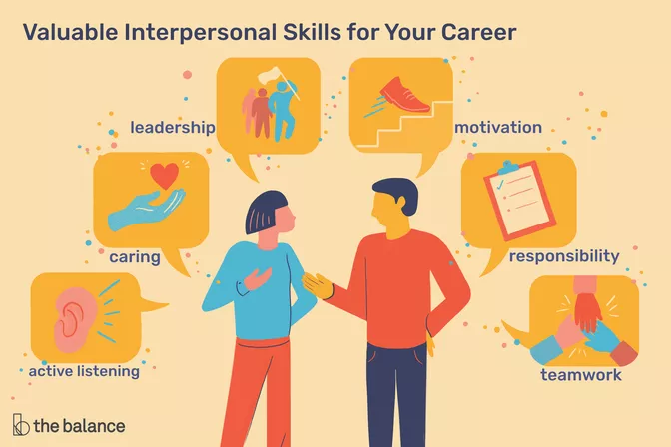

**Objectivies:**

**1.To help the students learn sub skills related to interpersonal skills**

**2.To equip them to interact in groups as a team.**

**3.To make them learn how to cooperate and coordinate in a group as a team.**

**Pre-Lab Questions:**

**1.What are interpersonal skills also called as?**

**---------------------------------------------------------------------------------------------------------------------------------------------------------------------------------------------------------------------------------------------------------------------------------------------------------------------------------------**

**2.Why are they important in a work place?**

**---------------------------------------------------------------------------------------------------------------------------------------------------------------------------------------------------------------------------------------------------------------------------------------------------------------------------------------**

**What are interpersonal skills, and why are they important in the workplace? Interpersonal skills, also known as people skills or emotional intelligence, are related to the way you communicate and interact with others.**

**When employers are hiring, interpersonal skills are one of the top criteria used to evaluate candidates. They are also important skills that will help you promoted and be successful in the workplace. Regardless of the type of job you have, it’s important to be able to get along well with coworkers, managers, customers, and vendors.**

**What Are Interpersonal Skills?**

**Interpersonal skills are sometimes called employability skills. The word “employability” is a tip-off about the importance of interpersonal skills: they’re so crucial that hiring managers really don’t want to hire candidates without them.**

**Many careers require consistent, if not constant, interaction with other people. This is true even for jobs that would seem to favor introverted personalities and independent work styles. For example, even if you’re a software engineer, writer, or statistician, you still need to be able to communicate and collaborate with your team.**

**Types of Interpersonal Skills**

**Interpersonal skills include verbal and nonverbal communication, the ability to handle conflict, teamwork, empathy, listening, and a positive attitude. Being flexible and positive, able to listen, and communicating well are important criteria for success at work.**

**Communication**

**One of the most important interpersonal skills in any job is communication. Whether you work in IT, customer service, construction, or any other industry, you will need to be able to communicate clearly and effectively with others both verbally and in writing. Some jobs also require skills in effective public speaking.Nonverbal communication**

**Public speaking**

**Verbal communication**

**Conflict Management**

**Whether you are a manager or an employee, you will likely need to resolve conflicts at some point in your job. This might involve solving an issue between two staff members, between yourself and a colleague, or between a client and your company. You will need to be able to listen fairly to both sides and use creative problem-solving to arrive at a solution.**

**Conflict resolution**

**Constructive criticism**

**Counseling**

**Mediating**

**Problem-solvingEmpathy**

**Part of being a good manager, employee, or colleague is the ability to understand and show empathy to others. If a customer or colleague calls with a complaint, for example, you will need to listen thoughtfully to the person’s concerns and express compassion for their issue. Empathy is an important skill that will help you get along with everyone in the workplace.**

**Caring**

**Compassion**

**Diplomacy**

**Diversity**

**Helping others**

**Kindness**

**Patience**

**Respect**

**Sensitivity**

**Sympathy**

**Leadership**

**Even if you are not a manager, it is important to have some leadership experience and ability. Leadership requires being able to motivate and encourage others and help a team achieve success.**

**Encouraging**

**Inspiring trust**

**Instructing**

**Management**

**Mentoring**

**Motivation**

**Positive reinforcementListening**

**Listening is a skill that goes hand in hand with good communication. While you need to be able to express your own ideas, you also need to thoughtfully listen to the ideas of others. This will help your clients, employers, colleagues, and employees feel respected and valued.**

**Active listening**

**Curiosity**

**Focus**

**Inquiry**

**Negotiation**

**Negotiation is an important skill for many positions. Depending on the specific job, it might involve creating formal agreements (or contracts) between clients or helping colleagues solve a problem and determine a solution. To be a good negotiator, you must be able to listen to others, use creative problem solving, and arrive at an outcome that satisfies everyone.Negotiating**

**Persuasion**

**Research**

**Positive Attitude**

**Employers want to hire employees who make the office a brighter place. They want people with a friendly, positive demeanor. This doesn’t mean you have to be the most social person in the office, but you must be willing to develop some sort of a positive rapport with your colleagues.**

**Behavioral skills**

**Developing rapport**

**Friendliness**

**Humor**

**Networking**

**Social skills**

**Teamwork**

**Even if your job involves a lot of independent work, you still need to be able to collaborate with others. Teamwork involves several of the skills already mentioned: you need to be able to listen to others, communicate your own goals, motivate your team, and resolve any conflicts that may arise.**

**Collaboration**

**Group facilitating**

**Team building**

**TeamworkIn-Demand Interpersonal Skills to Highlight**

**Preparing for a job interview, working on a promotion, or customizing your resume or cover letter? These are some of the most sought-after interpersonal skills. Look for ways to weave some of these keywords into your application materials or conversation.**

**Active listening**

**Behavioral**

**Caring**

**Collaboration**

**Comforting**

**Communication**

**Conflict management**

**Conflict resolution**

**Consulting**

**Constructive criticism**

**Counseling**

**Creative thinking**

**Customer service**

**Developing rapport**

**Diplomacy**

**Diversity**

**Encouraging**

**Flexibility**

**Group facilitating**

**Helping others**

**Humor**

**Inquiry**

**Inspiring trust**

**Instructing**

**Interviewing**

**Leadership**

**Listening**

**Mediating**

**Mentoring**

**Motivation**

**Negotiating**

**Networking**

**Nonverbal communication**

**Patience**

**Persuasion**

**Positive reinforcement**

**Problem-solving**

**Public speaking**

**Relationship management**

**Respect**

**Responsibility**

**Sensitivity**

**Social skills**

**Sympathy**

**Teamwork**

**Tolerance**

**Verbal communication**

**Post-Lab questions:**

**What is the difference between the verbal and non-verbal communication?**

**---------------------------------------------------------------------------------------------------------------------------------------------------------------------------------------------------------------------------------------------------------------------------------------------------------------------------------------------------------------------------------------------------------------------------------------------------------------------------------------------------------------------------------------------------------------------------------------------------------------------------------------------------------------------------------------------------------------------------------------------------------------------------------------------------------------------------------------------------------------------------------------------------------------------------------------------------------------------------------------------------------------------------------------------------------------------------------------------------------------------------------------------------------------------------------------**

**How can you differentiate the inter personal skills from the intra personal skills?**

**------------------------------------------------------------------------------------------------------------------------------------------------------------------------------------------------------------------------------------------------------------------------------------------------------------------------------------------------------------------------------------------------------------------------------------------------------------------------------------------------------------------------------------------------------------------------------------------------------------------------------------------------------------------------------------------------------------------------------------------------------------------------------------------------------------------------------------------------------------------------------------------------------------------------------------------------------------------------------------------------------------------------------------------------------------------------------------------------------------------------------------------------------------------------------------------------------------------------------------------------------------------------------------------------------------------------------------------------------------------------------------------------------------------------------------------------------------------------------------------------------------------------------------------------------------------------------------**

**Define the following terms:**

1. **Time management**

**------------------------------------------------------------------------------------------------------------------------------------------------------------------------------------------------------------------------------------------------------------------------------------------------------------------------------------------------------------------------------------------------------------------------------------------------------------------------------------**

1. **Team work**

**------------------------------------------------------------------------------------------------------------------------------------------------------------------------------------------------------------------------------------------------------------------------------------------------------------------------------------------------------------------------------------------------------------------------------------------------------------------------------------**

1. **Decision making**

**------------------------------------------------------------------------------------------------------------------------------------------------------------------------------------------------------------------------------------------------------------------------------------------------------------------------------------------------------------------------------------------------------------------------------------------------------------------------------------**

1. **Stress management**

**------------------------------------------------------------------------------------------------------------------------------------------------------------------------------------------------------------------------------------------------------------------------------------------------------------------------------------------------------------------------------------------------------------------------------------------------------------------------------------**

1. **Creative thinking**

**------------------------------------------------------------------------------------------------------------------------------------------------------------------------------------------------------------------------------------------------------------------------------------------------------------------------------------------------------------------------------------------------------------------------------------------------------------------------------------**

1. **Negotiation**

**------------------------------------------------------------------------------------------------------------------------------------------------------------------------------------------------------------------------------------------------------------------------------------------------------------------------------------------------------------------------------------------------------------------------------------------------------------------------------------**

**(g)Adaptability**

**------------------------------------------------------------------------------------------------------------------------------------------------------------------------------------------------------------------------------------------------------------------------------------------------------------------------------------------------------------------------------------------------------------------------------------------------------------------------------------**

**How to Make Your Skills Stand Out**

**SHOW DON'T TELL:**

**Whether you're interviewing for a new job or looking for a promotion, be sure to use your interpersonal skills to make a good impression.**

**BRUSH UP YOUR SKILLS:**

**If your skills need improving or your confidence could use a boost, there are online and offline courses and seminars you can take.**

**BE NICE:**

**One of the best ways to show that you've got strong interpersonal skills is to remain calm and civil, even in stressful situations.**

|  |  |  |  |  |  |  |
| --- | --- | --- | --- | --- | --- | --- |
| **Date of submission** |  |  |  |  |  |  |
| **Name of the Evaluator** |  |  |  |  |  |  |
| **Marks**  **Awarded** | **Pre lab questions**  **(2M)** | **Format and structure**  **(2M)** | **Content**  **(2M)** | **Language and Tone**  **(2M)** | **Post Lab Questions**  **(2M)** | **Total**  **(10M)** |
|  |  |  |  |  |  |
| **Remarks** |  |  |  |  |  |  |
| **Signature of the Evaluator with Date** |  |  |  |  |  |  |

**Grading:**

j

ACTIVITY4:DEBATE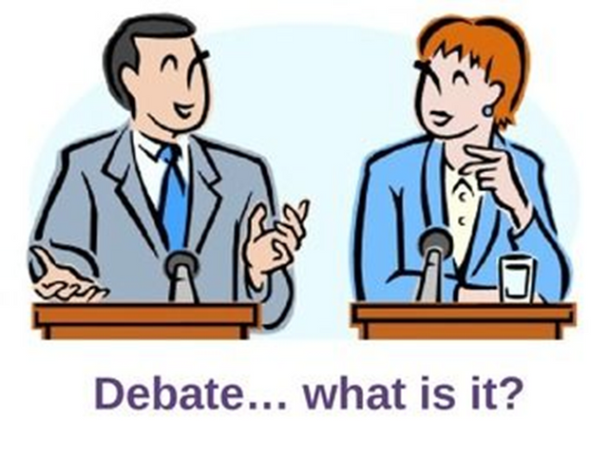

Objectivies:

1.To enable the students to discuss the facts and contribute ideas for the argument.

2,To utilize the related statistics and present a cumilative summary of the details.

Pre-Lab Questions:

1.What is your understanding of a Debate?

----------------------------------------------------------------------------------------------------------------------------------------------------------------------------------------------------------------------------------------------------------------------------------------------------------------------------------------------------------------------------------------------------------------

2.According to you,how does a debate improve the communicative skills?

----------------------------------------------------------------------------------------------------------------------------------------------------------------------------------------------------------------------------------------------------------------------------------------------------------------------------------------------------------------------------------------------------------------

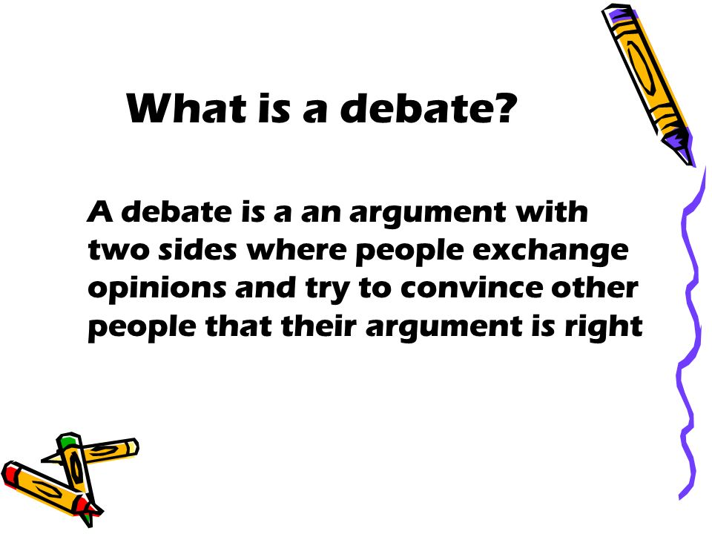

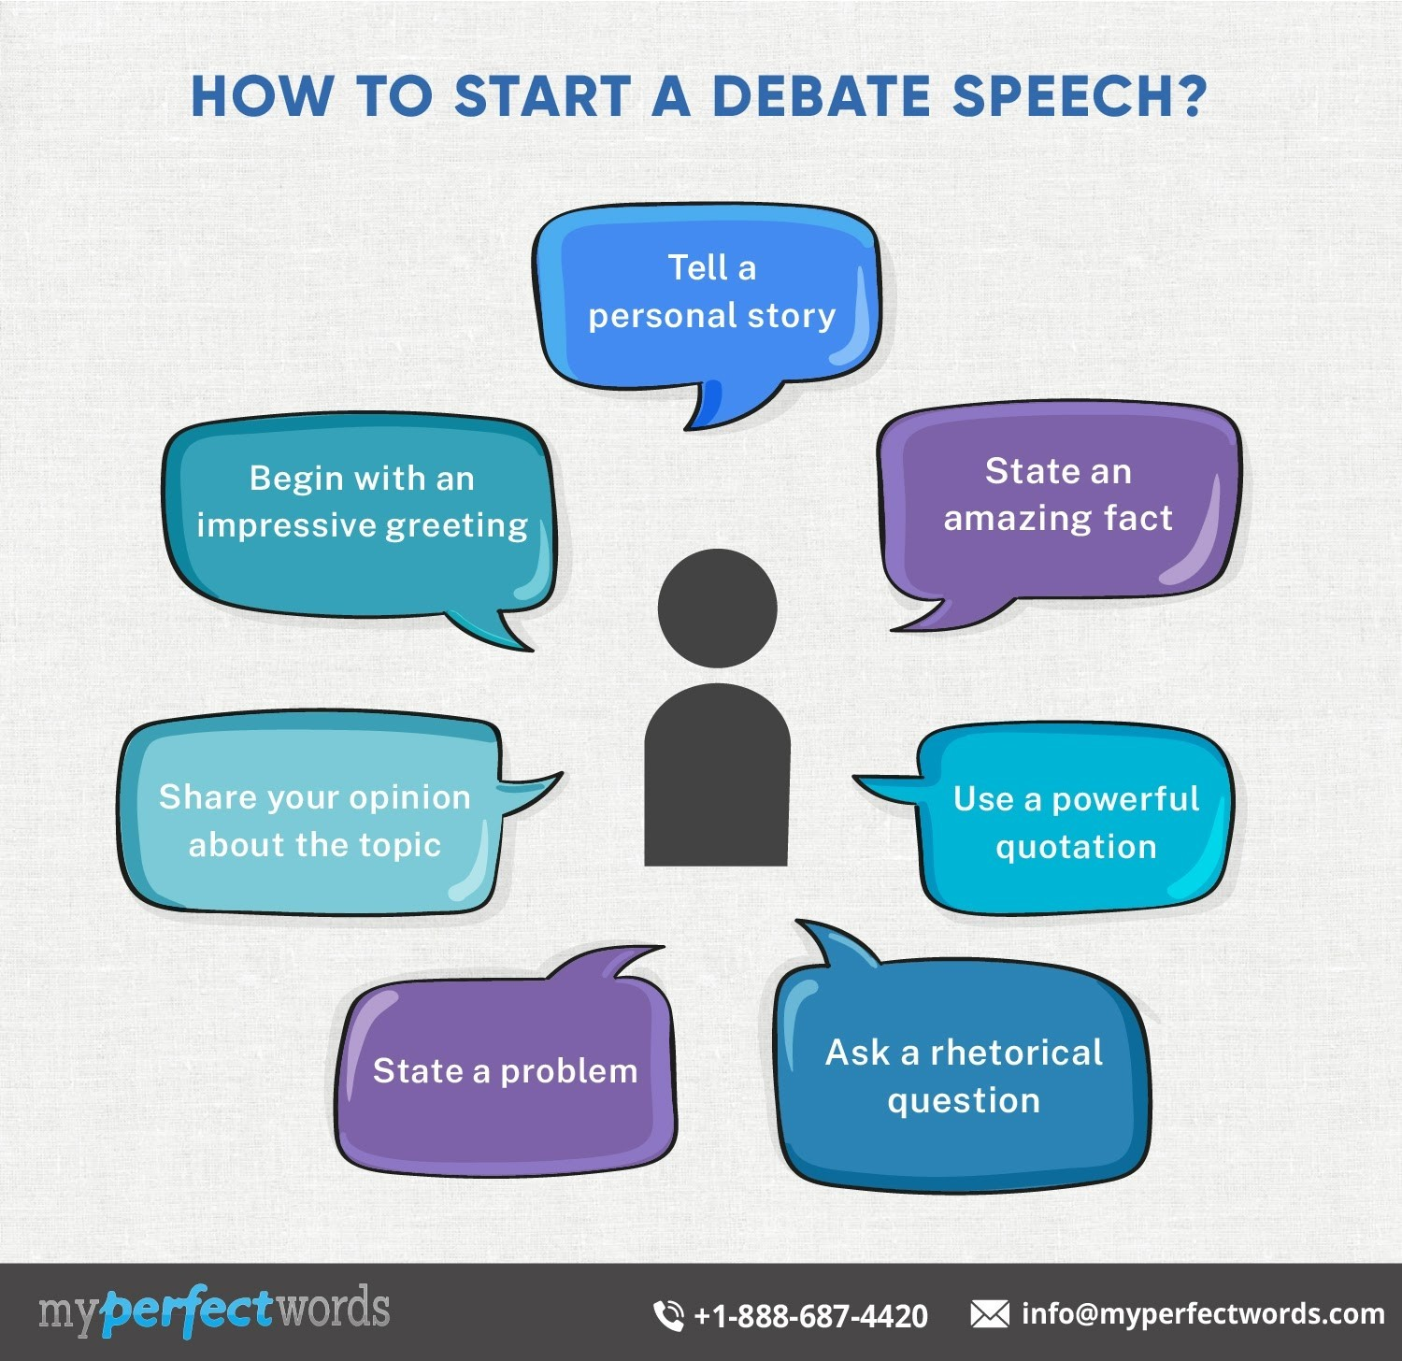

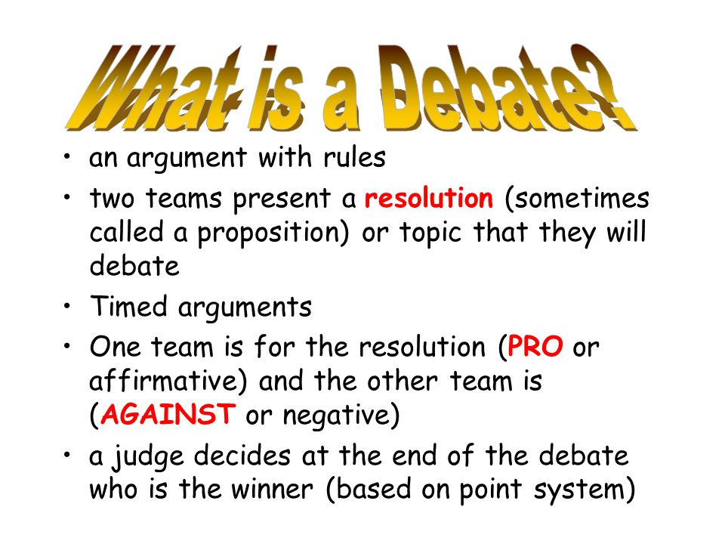 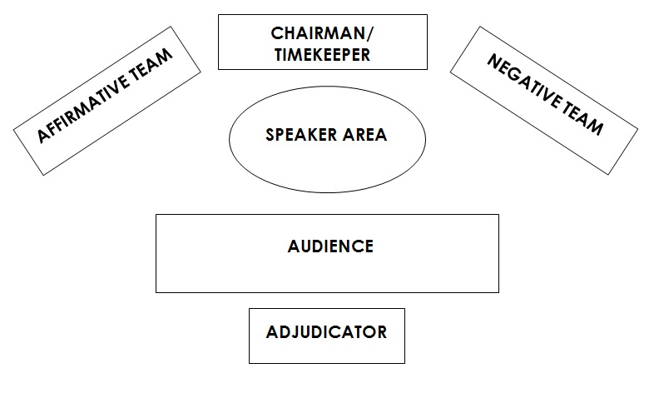

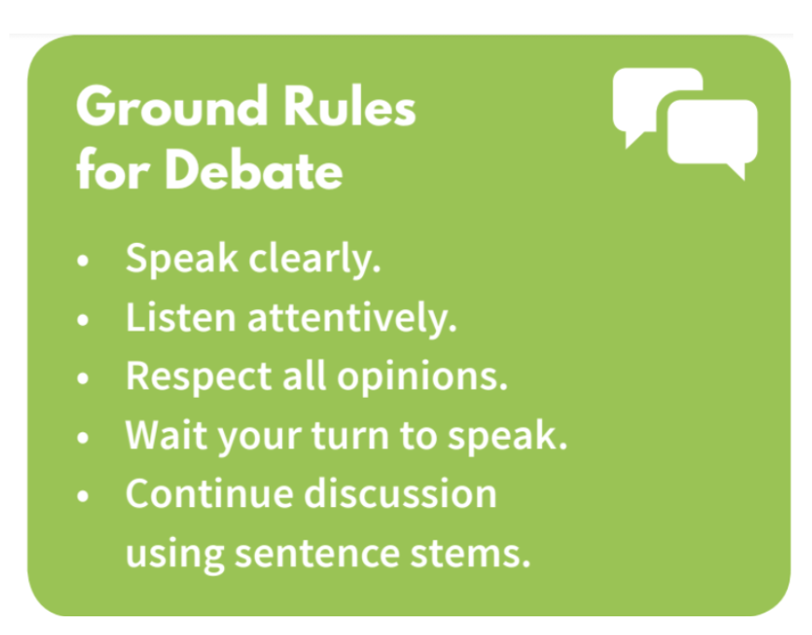

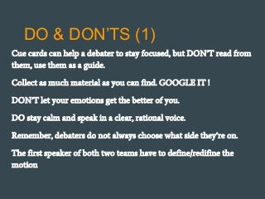

Post-Lab Questions:

What is a Debate?What are the rules to be followed in a Debate?

------------------------------------------------------------------------------------------------------------------------------------------------------------------------------------------------------------------------------------------------------------------------------------------------------------------------------------------------------------------------------------------------------------------------------------------------------------------------------------------------------------------------------------------------------------------------------------------------------------------------------------------------------------------------------------------------------------------------------------------------------------------------------------------------------------------------------------------------------------------------------------------------------------------------------------------------------------------------------------------------------------------------------------------------------------------------------------------------------------------------------------------------------------------------------------------------------------------------------------------------------------------------------------------------------------------------------------------------------------------------------------------------------------------------------------------------------------------------------------------------------------------------------------------------------------------------------------

Outcomes:

Upon completion of the session,the student will be able to

1.Develop debating skills and moulds them to become a good debator.

2.Demonstrate professionalism and competence among peers.

3.Improve competitive spirit at conversational level.

Grading:

|  |  |  |  |  |
| --- | --- | --- | --- | --- |
| Date of submission |  |  |  |  |
| Name of the Evaluator |  |  |  |  |
| Marks awarded  (Max.Marks-10M) | Pre –Lab Questions  (2M) | Activity  (6M) | Post-Lab Questions  (2M) | Total  (10M) |
|  |  |  |  |
| Remarks |  |  |  |  |
| Signature of the Evaluator with Date |  |  |  |  |

GROUP DISCUSSION

Activity:5

Objectivies

1.To understand the characteristics of a succesful group discussion.

2.To identify areas of evaluation in GDs conducted by organisations as apart of the selection procedure.

3.To chalk out the strategies to exchange opinions and suggestions in a group discussion.

Pre-Lab Questions:

1.What is your understanding of a Group Discussion?

---------------------------------------------------------------------------------------------------------------------------------------------------------------------------------------------------------------------------------------------------------------------------------------------------------------------------------------------------------------------------------------------------------------------------------------------------------------------------------------------------------------------------

2.According to you,how does a group discussion improve your communicative skills?

-----------------------------------------------------------------------------------------------------------------------------------------------------------------------------------------------------------------------------------------------------------------------------------------------------------------------------------------------------------------------------------------------------------------------------------------------------------------------------------------------------------------------------

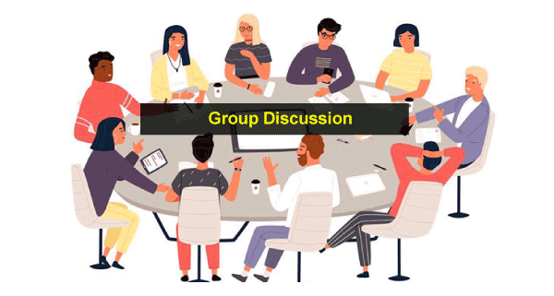

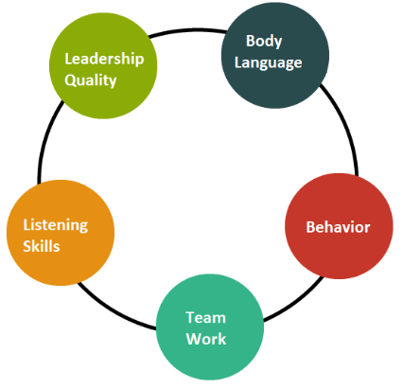

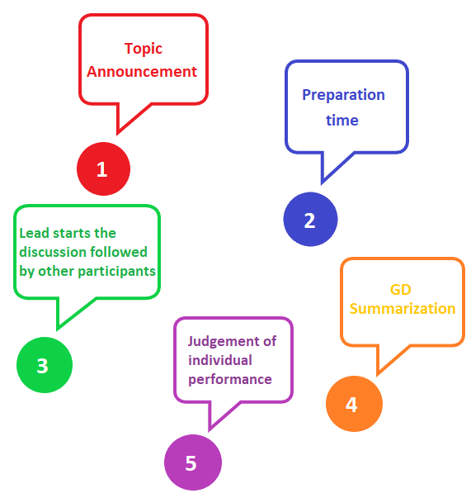

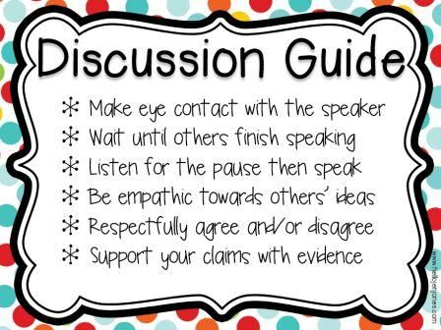

Post-Lab Questions:

What is a Group Discussion? What are the rules to be followed in a Group Discussion?

---------------------------------------------------------------------------------------------------------------------------------------------------------------------------------------------------------------------------------------------------------------------------------------------------------------------------------------------------------------------------------------------------------------------------------------------------------------------------------------------------------------------------------------------------------------------------------------------------------------------------------------------------------------------------------------------------------------------------------------------------------------------------------------------------------------------------------------------------------------------------------------------------------------------------------------------------------------------------------------------------------------------------------------------------------------------------------------------------------------------------------------------------------------------------------------------------------------------------------------------------------------------------------------------------------------------------------------------------------------------------------------------------------------------------------------------------------------------------------------------------------------------------------------------------------------------------------------------------------------------------------------------------------------------------------------------------

2.List out few qualities of a participent in a group discussion?

------------------------------------------------------------------------------------------------------------------------------------------------------------------------------------------------------------------------------------------------------------------------------------------------------------------------------------------------------------------------------------------------------------------------------------------------------------------------------------------------------------------------------------------------------------------------------------------------------------------------------------------------------------------------------

Outcomes:

Upon completion of this session,student will be able to

1.Broden the outlook of the participents through cross fertilization and exposure to new and different experiences and ideas and enrich their understanding of the issues under the discussion.

2.Develop their skills in intrepersonal communication and in expressing their views in a clear and succinct manner.

|  |  |  |  |  |
| --- | --- | --- | --- | --- |
| Date of submission |  |  |  |  |
| Name of the Evaluator |  |  |  |  |
| Marks awarded  (Max.Marks-10M) | Pre –Lab Questions  (2M) | Activity  (6M) | Post-Lab Questions  (2M) | Total  (10M) |
|  |  |  |  |
| Remarks |  |  |  |  |
| Signature of the Evaluator with Date |  |  |  |  |

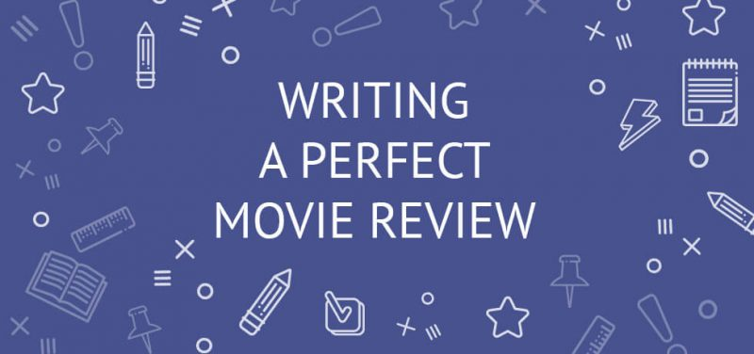

Activity:6:Reviewing a Book/Film

Objectives:

1.To demonstrate reading comprehension through the communication of ideas including summerising texts and identifying relationships between texts.

2.Write to inform and persuade others about literature and other informational texts.

3.To make the students read for personal growth and pleasure.

Pre-Lab Questions:

1.What is meant by book reviewing?

----------------------------------------------------------------------------------------------------------------------------------------------------------------------------------------------------------------------------------------------------------------------------------------------------------------------------------------------------------------------------------------------------------------------------------------------------

2.Have you ever judge an author based upon the book review?

----------------------------------------------------------------------------------------------------------------------------------------------------------------------------------------------------------------------------------------------------------------------------------------------------------------------------------------------------------------------------------------------------------------------------------------------------

**How to write a book or film review**

**Writing a book/film review**

Do you know how to write a book or a film review? Follow these steps.

Pre writing

Remember and take notes of the plot of the story. What impression did it produce on you?

Writing

Introduction:

Give the title and author of the book, mention the type of the book. If you’re reviewing a film

mention the type of film, the director and the actors.

Body:

Summarize the plot in a few sentences.

Mention the setting: the place and time of the plot.

Say something about the main characters.

Say something about the content.

Conclusion:

Comment on the book or film.

Let others know whether or not you liked the book/film.

Give your opinion about the acting of the actors, sound  track, special effects.

Is the author’s style good or bad, is the book / film interesting or boring etc.

Do you want to recommend the book/film?

Post writing

Edit your writing.

Useful Expressions

Title, Author / Director, Actors

The film is directed by  
The film is produced by..  
It is starred by…  
The book is written by …

Setting

The action takes place in … (setting)  
The action of the film is set in …  
The story takes place in…

Characters and Plot

The main characters are …  
The story is about ….  
The novel tells the story of …  
In the course of the novel the action develops dramatically.  
The novel / film begins with…  
The novel has an unexpected ending.  
The end of … is …

Reaction

I am impressed by  
I think ….  
The book is terribly / beautifully written  
The film is terrible / exciting.  
What surprised me is …  
What I liked is…  
What I didn’t like is…  
I liked/didn’t like the film / novel because …

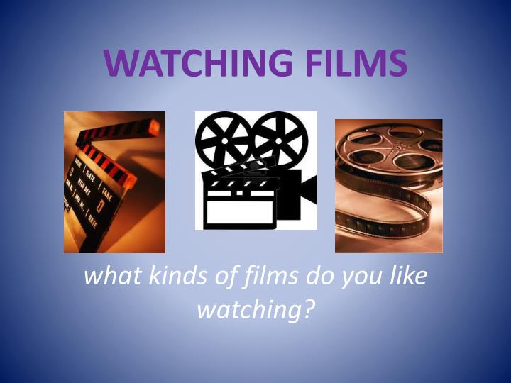

*Kinds of*[*films / movies*](https://in2english.net/2019/03/01/cinema-important-art-form/)

* **Action movies**have a lot of exciting effects like car chases and gun fight. They usually involve ‘goodies’ and ‘baddies’, so war and crime are common subjects. Action movies usually need very little effort to watch, since the plot is normally simple.
* **Adventure movies** usually involve a hero who sets out on a quest to save the world or loved ones.
* **Animated movies**
* **Comedies**are funny movies about people being silly or doing unusual things that make the audience laugh.
* **Documentaries**are movies that are about real people and real events. They are nearly always serious and may involve strongly emotional subjects, for example cruelty.
* **Dramas**are serious, and often about people falling in love or needing to make a big decision in their life. They tell stories about relationships between people.
* **Tragedies**are always dramas, and are about people in trouble. For example, a husband and wife who are divorcing must each try to prove to a court of law that they are the best person to take care of their child. Emotion (feelings) are a big part of the movie and the audience (people watching the movie) may get upset and even cry.
* **Family movies** are made to be good for the entire family. They are mainly made for children but often entertaining for adults as well. Disney is famous for their family movies.
* **Horror movies** use fear to excite the audience. Music, lighting and sets (man-made places in movie studios where the movie is made) are all designed to add to the feeling.
* **Romantic Comedies**(Rom-Coms) are usually love stories about 2 people from different worlds, who must overcome obstacles to be together. Rom-Coms are always light-hearted, but may
* include some emotion.
* **Science fiction (sci-fi)** movies are set in the future or in outer space. Some use their future or alien settings to ask questions about the meaning of life or how we should think about life. Science fiction movies often use special effects to create images of alien worlds, outer space, alien creatures, and spaceships.
* **Thrillers**are usually about a mystery, strange event, or crime that needs to be solved. The audience is kept guessing until the final minutes, when there are usually ‘twists’ in the plot (surprises).
* **Western movies** tell stories about cowboys in the western United States in the 1800s. They are usually really action movies, but with historical costume. They may or may not involve Indians (Native Americans).
* **Fantasy**movies include magical and impossible things that any real human being cannot do.

*Review Sample*



One of my favourite films is one of the Star Wars series. I’ve got the video. It’s an exciting science fiction film and it’s called *The Phantom Menace*. It’s the first part of a trilogy about a boy called Anakin Skywalker.

In this film Anakin is nine years old and he lives with his mother on planet Tatsin. Strange-looking creatures rule this planet and Anakin and all the other human beings are slaves. Anakin’s dream is to become one of the Jedi knights, the brave guardians of the galaxy, and free his people. One day two Jedi knights land on Tatsin and Anakin thinks his dream might finally come true.

I enjoy watching this film because it’s never boring. The story is full of surprises and suspense. And the action never stops. There are spaceship races, battles with robots and really exciting fight scenes with the Jedi knights. I like those the best. Also, the space scenes and the different creatures on the planets are amazing and they look so real.

You must go and see this film or get the video. You may not like science fiction but this film is special. The story is exciting and the scenery and acting is brilliant. And it’s not just a film for children. All the family should see it. I can’t wait to see the next two films in the trilogy.

Post-Lab Questions:

1.What is the purpose of book review?

2.How do you write a book review?

----------------------------------------------------------------------------------------------------------------------------------------------------------------------------------------------------------------------------------------------------------------------------------------------------------------------------------------------------------------------------------------------------------------------------------------------------

3.Write the review of any film/book you have watched before?

----------------------------------------------------------------------------------------------------------------------------------------------------------------------------------------------------------------------------------------------------------------------------------------------------------------------------------------------------------------------------------------------------------------------------------------------------------------------------------------------------------------------------------------------------------------------------------------------------------------------------------------------------------------------------------------------------------------------------------------------------------------------------------------------------------------------------------------------------------------------------------------------------------------------------------------------------------------------------------------------------------------------------------------------------------------------------------------------------------------------------------------------------------------------------------------------------------------------------------------------------------------------------------------------------------------------------------------------------------------------------------------------------------------------------------------------------------------------------------------------------------------------------------------------------------------------------------------------------------------------------------------------------------------------------------------------------------------------------------------------------------------------------------------------------------------------------------------------------------------------------------------------------------------------------------------------------------------------------------------------------------------------------------------------------------------------------------------------------------------------------------------------------------------------------------------------------------------------------------------------------------------------------------------------------------------------------------------------------------------------------------------------------------------------------------------------------------------------------------------------------------------------------------------------------------------------------------------------------------------------------------------------------------------------------------------------------------------------------------------------------------------------------------------------------------------------------------------------------------------------------------------------------------------------------------------------------------------------------------------------------------------------------------------------------------------------------------------------------------------------------------------------------------------------------------------------------------------------------------------------------------------------------------------

Outcomes:

At the end of this session,students will be able to learn

1.To develop reading and comprehension skills.

2.To provide in-depth training in how to use the literary devices.

3.To develop thorough description,critical analysis,evaluation of quality,meaning and significance of a book.

|  |  |  |  |  |  |  |
| --- | --- | --- | --- | --- | --- | --- |
| **Date of submission** |  |  |  |  |  |  |
| **Name of the Evaluator** |  |  |  |  |  |  |
| **Marks**  **Awarded** | **Pre lab questions**  **(2M)** | **Format and structure**  **(2M)** | **Content**  **(2M)** | **Language and Tone**  **(2M)** | **Post Lab Questions**  **(2M)** | **Total**  **(10M)** |
|  |  |  |  |  |  |
| **Remarks** |  |  |  |  |  |  |
| **Signature of the Evaluator with Date** |  |  |  |  |  |  |

Grading:

CONFLICT RESOLUTION SKILLS

Activity:7

Objectives:

1.To enable the students learn, how to handle any kind of situation in a work place.

2.To make them learn how to find a solution to a particular problem at a work place.

Pre-Lab Questions:

1.What is ment by conflict resolution?

----------------------------------------------------------------------------------------------------------------------------------------------------------------------------------------------------------------------------------------------------------------------------------------------------------------------------------------------------------------------------------------------------------------------------------------------------------------------------------------------------------------------------

2.Conflict resolution is a sub skill related to hard skills or soft skills,explain why?

-----------------------------------------------------------------------------------------------------------------------------------------------------------------------------------------------------------------------------------------------------------------------------------------------------------------------------------------------------------------------------------------------------------------------------------------------------------------------------------------------------------------------------------------------------------------------------------------------------------------------------------------------------------

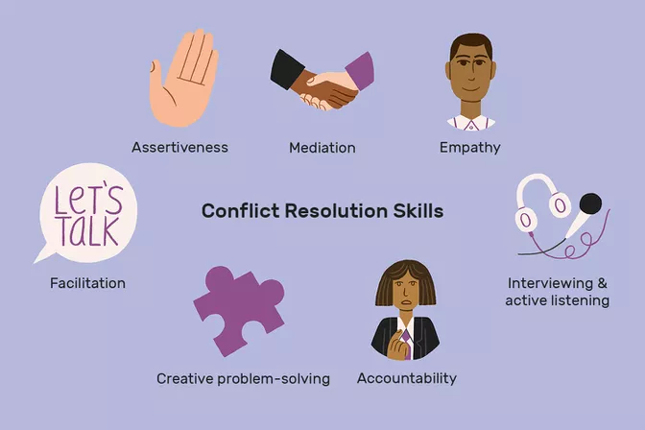

**Conflict resolution skills are required for a wide range of positions across many job sectors. This requirement is based on the fact that conflict tends to reduce productivity and create a difficult work environment, leading to unwanted turnover in staff and reduced morale.**

**Individuals who are able to resolve conflicts are often excellent mediators, rational, and able to manage difficult personalities from a place of empathy.**

**Learn about conflict resolution, including types of conflict resolution, examples, and how the conflict resolution process works.**

**What Is Conflict Resolution?**

**Conflict resolution is the process by which two or more parties reach a peaceful resolution to a dispute.**

**In the work place there can be variety of types of conflictsConflict may occur between co-workers, between supervisors and subordinates, or between service providers and their clients or customers.**

**Conflict can also occur between groups, such as management and the labor force, or between entire departments. The Conflict Resolution Process**

**The resolution of conflicts in the workplace typically involves some or all of the following processes:**

**Recognition by the parties involved that a problem exists.**

**Mutual agreement to address the issue and find some resolution.**

**An effort to understand the perspective and concerns of the opposing individual or group.**

**Identifying changes in attitude, behavior, and approaches to work by both sides that will lessen negative feelings.**

**Recognizing triggers to episodes of conflict.**

**Interventions by third parties such as human resources representatives or higher-level managers to mediate.**

**A willingness by one or both parties to compromise.**

**Agreement on a plan to address differences.**

**Monitoring the impact of any agreements for change.**

**Disciplining or terminating employees who resist efforts to defuse conflicts.**

**Post-Lab Questions:**

**1.What is conflict resolution?what are the skills related to it?**

**-------------------------------------------------------------------------------------------------------------------------------------------------------------------------------------------------------------------------------------------------------------------------------------------------------------------------------------------------------------------------------------------------------------------------------------------------------------------------------------------------------------------------------------------------------------------------------------------------------------------------------------------------------------------------------------------------------------------------------------------------------------------------------------------------------------------------------------------------------------------------------------------------------------------------------------------------------------------------------------------------------------------------------------------------------------------------------------------------------------------------------------------------------------------------------------------------------------------------------------------------------------------------------------------------------------------------------------------------------------------------------------------------------------------------------------------------------------------------------------------------------------------------------------------------------------------------------------------------------------------------------------------------------------------------------------------------------------------------------------------------------------------------------------------------------------------------------------------------------------------------------------------------------------------------------------------------------------------------------------------------------------------------------------------------------------------------------------------------------------------------------------------------------------------------------------------------------------------------------Outcomes:**

**After the completion of this session students wil be able to learn**

**1.How to handle any kind of situation at a workplace.**

**2.They learn how to resolve the conflict by analysing the problem and making it as simple as possible.**

|  |  |  |  |  |  |  |
| --- | --- | --- | --- | --- | --- | --- |
| **Date of submission** |  |  |  |  |  |  |
| **Name of the Evaluator** |  |  |  |  |  |  |
| **Marks**  **Awarded** | **Pre lab questions**  **(2M)** | **Format and structure**  **(2M)** | **Content**  **(2M)** | **Language and Tone**  **(2M)** | **Post Lab Questions**  **(2M)** | **Total**  **(10M)** |
|  |  |  |  |  |  |
| **Remarks** |  |  |  |  |  |  |
| **Signature of the Evaluator with Date** |  |  |  |  |  |  |

**Active Listening Definition, Skills, and Examples**

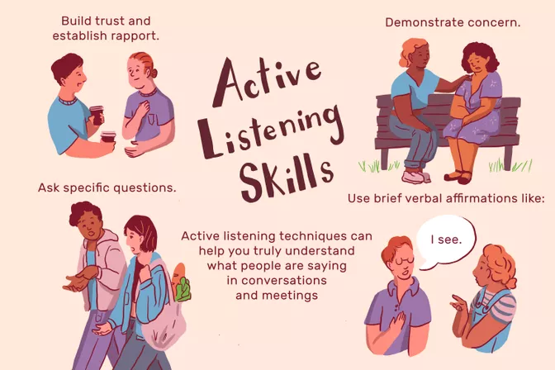

**Activity:8 Active Listening skills**

**Objectivies:**

**1.To enable the students listen attentively when something is being said.**

**2.To promote active listening skills in them through activities.**

**Pre-Lab Questions:**

1. **What is active listening ?why is it important for your career?**

**----------------------------------------------------------------------------------------------------------------------------------------------------------------------------------------------------------------------------------------------------------------------------------------**

1. **Does it play a vital role in our life?What are the benefits of Active listening?**

**------------------------------------------------------------------------------------------------------------------------------------------------------------------------------------------------------------------------------------------------------------------------------------------------------------------------------------------------------------------------------------------------------------------**

**What is active listening, and why is it important for your career? Active listening is the process by which an individual secures information from another individual or group.**

**It involves paying attention to the conversation, not interrupting, and taking the time to understand what the speaker is discussing. The “active” element involves taking steps to draw out details that might not otherwise be shared.**

**Active listening is a helpful skill for any worker to develop. It helps you truly understand what people are saying in conversations and meetings (and not just what you want to hear, or think you hear).**

**Active listening is a particularly useful tool to use during job interviews, since itcan help you build positive rapport with your interviewer.**

**What Is Active Listening?**

**Like critical thinking and problem-solving skills, active listening is a soft skill that’s held in high regard by employers. When interviewing for jobs, using active listening techniques can show the interviewer how your interpersonal skills can draw people out.**

**Active listening redirects your focus from what is going on inside of your head to the needs of your prospective employer or interviewer. This technique can help reduce your nervousness during an interview.**

**By placing your focus, through active listening, squarely upon the interviewer, you prove that you:**

**Are interested in the organization’s challenges and successes**

**Are ready to help them solve work issues**

**Are a team player, as opposed to being nothing more than a self-absorbed job candidate.**

**Examples of Active Listening Techniques**

**There are plenty of active listening techniques that will improve the impression you can make at a job interview.**

**Active listening techniques include:**

**Building trust and establishing rapport**

**Demonstrating concern**

**Paraphrasing to show understanding**

**Using nonverbal cues that show understanding such as nodding, eye contact, and leaning forward**

**Brief verbal affirmations like “I see,” “I know,” “Sure,” “Thank you,” or “I understand”**

**Asking open-ended questions**

**Asking specific questions to seek clarification**

**Waiting to disclose your opinion**

**Disclosing similar experiences to show understanding**

**By employing these active listening techniques, you will impress your**

**interviewer as a thoughtful, analytical, and highly desirable candidate for the position. Think about possible situations that may occur during an interview and come up with strategies to allow you to listen actively.**

**Examples of Active Listening Responses**

**It’s often easier to learn by reading examples. Here are some examples of statements and questions employed with active listening:**

**Building trust and establishing rapport: “Tell me what I can do to help.” “I was really impressed to read on your website how you donate 5% of each sale to charity.”**

**Demonstrating concern: “I'm eager to help; I know you're going through some tough challenges.” “I know how hard a corporate restructuring can be. How is staff morale at this point?”**

**Paraphrasing: “So, you're saying that the uncertainty about who will be your new supervisor is creating stress for you.” “So, you think that we need to build up our social media marketing efforts.”**

**Brief verbal affirmation: “I understand that you'd like more frequent feedback about your performance.” “Thank you. I appreciate your timein speaking to me.”**

**Asking open-ended questions: “I can see that John's criticism was very upsetting to you. Which aspect of his critique was most disturbing?” “It’s clear that the current situation is intolerable for you. What changes would you like to see?”**

**Asking specific questions: “How long do you expect your hiring process to last?” “What is your average rate of staff turnover?”**

**Waiting to disclose your opinion: “Tell me more about your proposal to reorganize the department.” “Can you please provide some history for me regarding your relationship with your former business partner?”**

**Disclosing similar situations: “I was also conflicted about returning to work after the birth of my son.” “I had the responsibility of terminating some of my personnel, due to downsizing, over the last two years. Even if it’s necessary, it never gets easier.”**

**Active Listening Skills**

**Validation**

**Emotional Intelligence**

**Problem Sensitivity**

**Courtesy**

**Professionalism**

**Nonverbal Communication**

**Transparency**

**Integrity**

**Humility**

**Proactivity**

**Accepting Constructive Criticism**

**Creating and Managing Expectations**

**Confidence**

**Empathy**

**Compassion**

**Understanding**

**Observation**

**Attention to Detail**

**Vocal Tone**

**Sensitivity to Religious and Ethnic Diversity**

**Self-Awareness**

**Situational Awareness**

**Interpretation**

**Identify and Manage Emotions**

**Understanding Hidden Needs of Others**

**Body Language**

**Facilitating Group Discussion**

**Reaching Consensus**

**Post-Lab Questions:**

**1.What is active listening ?Do you think its important? And what are the skills related to it?**

**----------------------------------------------------------------------------------------------------------------------------------------------------------------------------------------------------------------------------------------------------------------------------------------------------------------------------------------------------------------------------------------------------------------------------------------------------------------------------------------------------------------------------------------------------------------------------------------------------------------------------------------------------------------------------------------------------------------------------------------------------------------------------------------------------------------------------------------------------------------------------------------------------------------------------------------------------------------------------------------------------------------------------------------------------------------------------------------------------------------------------------**

**2.Explain in detail thefollowing terms:**

**(a)Attention to detail**

**-----------------------------------------------------------------------------------------------------------------------------------------------------------------------------------------------------------------------------------------------------------------------------------------------------------------------------------------------------------------------------------------------------------------------------------------------------------------------------------------------------------------------------------------------------------------**

**(b)Empathy**

**-----------------------------------------------------------------------------------------------------------------------------------------------------------------------------------------------------------------------------------------------------------------------------------------------------------------------------------------------------------------------------------------------------------------------------------------------------------------------------------------------------------------------------------------------------------------**

**(c)Interpretation**

**-----------------------------------------------------------------------------------------------------------------------------------------------------------------------------------------------------------------------------------------------------------------------------------------------------------------------------------------------------------------------------------------------------------------------------------------------------------------------------------------------------------------------------------------------------------------**

**(d)Professionalism**

**-----------------------------------------------------------------------------------------------------------------------------------------------------------------------------------------------------------------------------------------------------------------------------------------------------------------------------------------------------------------------------------------------------------------------------------------------------------------------------------------------------------------------------------------------------------------**

**Outcomes:**

**1.After the completion of this session students are able to learn**

**1.What key role active listening plays in our day to day life regarding all the aspects.**

**2.They try to adopt good and effective listening skills.**

**Grading:**

|  |  |  |  |  |
| --- | --- | --- | --- | --- |
| **Date of submission** |  |  |  |  |
| **Name of the Evaluator** |  |  |  |  |
| **Marks awarded**  **(Max.Marks-10M)** | **Pre –Lab Questions**  **(2M)** | **Activity**  **(6M)** | **Post-Lab Questions**  **(2M)** | **Total**  **(10M)** |
|  |  |  |  |
| **Remarks** |  |  |  |  |
| **Signature of the Evaluator with Date** |  |  |  |  |

**Activity:9 How to answer “Tell me about yourself”**

**Objectives:**

**1.To make the students learn/practise how to introduce themselves with a proper ettiquete and body language.**

**2.To make sure that they follow all the rules and commands which are relevent to speak in the interview.**

**Pre-Lab Questions:**

**1.According to you,do u think its important to tell about yourself in an interview?If so why?**

**-----------------------------------------------------------------------------------------------------------------------------------------------------------------------------------------------------------------------------------------------------------------------------------------------------------------------------------------------------------------------------------------------------------------------------------------------------------------------------------------------------------------------------------------------------------------**

**2.Whats ment by the phrase’’Breaking the ice”?Do uou think its benifecial to you to” break the ice”at the time of your interview?**

**------------------------------------------------------------------------------------------------------------------------------------------------------------------------------------------------------------------------------------------------------------------------------------------------------------------------------------------------------------------------------------------------------------------------------------------------------------------------------------------------------------------------------------------------------------------------------------------------------------------------------------------------------------------------------------------------------------------------------------------------------------------------------------------**

**How to Answer "Tell Me About Yourself?" in an Interview:**

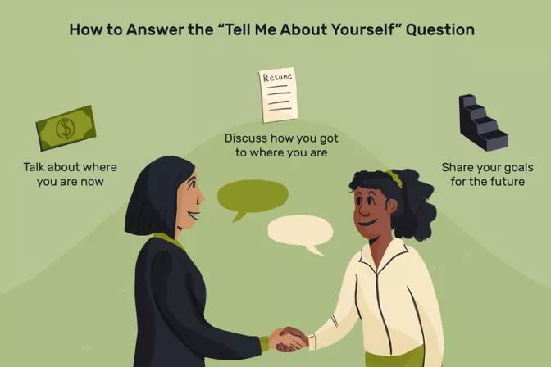

**Are you ready to talk about yourself during a job interview? Interviewers will sometimes start an interview with an open-ended question like, "Tell me about yourself."**

**This question is a way to break the ice and make you feel more comfortable during the interview process. However, some people might find this—and other interview questions about you—slightly stressful.**

**If you’re someone who doesn’t like bragging about yourself, these kinds of questions can be difficult to answer. But they’re a good way for the hiring manager to get insight into your personality, so it pays to prepare to answer them.**

**What the Interviewer Wants to Know**

**Interviewers ask these kinds of questions in order to determine if you're a good fit for the job.**

**Tip:**

**They’re looking not only for indications that you’re qualified to do the work,but that you’ll gel with the team and the company culture.**

**For example, a startup that lets employees bring dogs to work and has beers on tap in the breakroom will be inclined to hire the person who works at a no-kill shelter and/or brews their own beer. (Provided, of course, that the candidate possesses the hard skills they’re looking for, as well.)**

**The interviewer will also note how comfortable you appear answering open-ended questions. This will speak to your ability to think quickly on your feet, as well as to prepare for important conversations at work.**

**How to Answer the “Tell Me About Yourself” Interview Question**

**Although it might be tempting to share a list of your most compelling qualifications for the job, a more low-key approach will probably help you to develop a personal rapport with your interviewer.**

**One option for your response is to share some of your personal interests which don't relate directly to your career:**

**Examples might include a hobby that you are passionate about like quilting, astronomy, chess, choral singing, golf, skiing, tennis, or antiquing.**

**Interests like long-distance running or yoga that help to represent your healthy, energetic side are worth mentioning.**

**Pursuits, like being an avid reader or solving crossword puzzles or brain teasers, will help to showcase your intellectual leaning.**

**Interests like golf, tennis, and gourmet food might have some value if you would be entertaining clients in your new job.**

**Volunteer work will demonstrate the seriousness of your character and commitment to the welfare of your community.**

**Interactive roles like PTA volunteer, museum tour guide, fundraiser, or chair of a social club will help show your comfort with engaging others.**

**Remember, as with "tell me something about yourself that's not on your resume," one of the goals of this question is to get to know you a little bit beyond your career and on-the-job attitude and experience.**

**Use the Present-Past-Future Formula**

**If it feels daunting to generate an answer from scratch, you can rely on a simple formula to construct your answer. The “present-past-future” formula is a way to share key background points while ending on a high note.**

**Begin with a brief overview of where you are now (which could include your current job along with a reference to a personal hobby or passion)**

**Reference how you got to where you are (here you could mention education, or an important experience such as a past job, internship or volunteer experience) and**

**Finish by touching on a goal for the future.**

**Tip:Bonus points if you’re able to identify how the position you’re applying for aligns with how you envision your future.**

**Examples of the Best Answers**

**The best answers to this request are honest, brief, and confidently delivered. Your goal is to share something interesting about yourself that illuminates who you are as a person and an employee.**

**Come prepared with a few things to share and be sure to tie them to the skills and qualities that are most valuable in this job.**

**Example Answer #1**

**When I’m not working, I like to spend time exploring with my dogs. I take. I take them hiking, visiting historical sites, or even just walking around town. A surprising number of people are drawn to dogs, and I always enjoy talking with who I meet. I feel that communication is one of the most important aspects of my professional life as well. When talking with people, being able to guide the conversation in a particular direction is one of the ways I’ve been successful in different situations at the office.**

**Why It Works: In addition to sharing a seemingly unrelated fact (“she likes dogs!”) this answer also establishes that the candidate enjoys talking with people and understands the importance of communication—a valued skill in many roles.**

**Example Answer #2**

**I participate in charity walks several times a year. Recently, I did the Walk for Hunger and I have a few events planned for the summer and fall, as well. I walk for exercise with friends after work and on the weekends. I enjoy the fresh air, learning new routes, and connecting with new people. I also like the fundraising aspect, which has come in handy in my job. I’ve learned how to connect with people to increase their commitment to the cause.**

**Why It Works: This answer ties the candidate’s hobbies back to skills that are useful on the job and demonstrates that they’re responsible, community-minded person. Also, hobbies that involve fitness activities demonstrate energy and a commitment to health.**

**Example Answer #3**

**The past few years, I’ve gotten really into geocaching. I love the challenge of finding caches and spending time outdoors with friends. I like using my problem-solving skills to find the ones that are really well-hidden. Learning how people hide things—and where people are likely to look—has helped me tremendously in my design work. It’s all about learning to see things through someone else’s eyes.**

**Why It Works: This answer demonstrates an ability to learn from experience and work as a team, as well as an adventurous spirit.**

**Tips for Giving the Best Response**

**1:11**

**Transition to professional from personal. After sharing a few interesting personal aspects of your background, you can pivot to mentioning some key professional skills that would help you to add value if you were hired for your target job.**

**Consider using phrases like "In addition to those interests and passions, my professional life is a huge part of who I am, so I'd like to talk a bit about some of the strengths that I would bring to this job."**

**Share your expertise. Be ready to share three or four of the personal qualities, skills, and/or areas of expertise which would help you to excel in the job for which you are interviewing. Ultimately, you will want to mention several other strengths before the interview is over.**

**Make a list of your strengths before you go into the interview, so you know what you will share. Look at the job description and match it with your skills. Then make sure you talk about the top few skills which make you an ideal candidate for the job.**

**Be careful not to overwhelm the interviewer. After mentioning three or four strengths, you might mention that you have several other assets that you would like to discuss as the interview unfolds.**

**At first, you should only mention the asset and allude only briefly to some proof of how you have tapped it to your advantage. For example, you might say that you love to give presentations and that this has helped you to generate lots of leads at sales dinners for prospective clients. Later in the interview, you will want to be more specific and detailed in discussing situations, interventions, or results flowing from your strengths.**

**Be honest. It might be tempting to claim interest in hobbies or activities that seem like they’d appeal to the interviewer, but if you stretch the truth, it will become apparent pretty quickly. Get caught in a lie, and the interview will be over before it gets started. Worse, you could get hired and wind up spending years pretending that you’re an aspiring triathlete or competitive Scrabble player.**

**What Not to Say**

**Don’t share too much or too little information. The interviewer doesn't want to know everything about you, but disclosing too little can make him or her wonder why you aren't more open.**

**Avoid potentially contentious subjects such as political or religious leanings, unless you are absolutely positive that your opinions would be well-received by your interviewer.**

**Don’t talk about a hobby that might seem to be more important to you than your career. No employer wants to take a chance on hiring someone who will miss a lot of work or ask for extensive vacation time to pursue their passions outside of work.**

**Avoid sharing personal information about your family. There is no need to discuss spouses, partners, children, or any other strictly personal information.**

**Post-Lab questions:**

**1.What is your greatest strength?**

**---------------------------------------------------------------------------------------------------------------------------------------------------------------------------------------------------------------------------------------------------------------------------------------------------------------------------------------**

**2.What motivates you?**

**--------------------------------------------------------------------------------------------------------------------------------------------------------------------------------------------------------------------------------------------------------------------------------------------------------------------------------------**

**3.What are your goals for the future?**

**----------------------------------------------------------------------------------------------------------------------------------------------------------------------------------------------------------------------------------------------------------------------------------------------------------------------------------------------------------------------------------------------------------------------------------------------------**

**4.Why do you want this job?**

**----------------------------------------------------------------------------------------------------------------------------------------------------------------------------------------------------------------------------------------------------------------------------------------------------------------------------------------------------------------------------------------------------------------------------------------------------**

**Key Takeaways**

**BE HONEST:**

**Don’t claim hobbies and interests that aren’t your passions.**

**TIE YOUR ANSWER TO THE JOB:**

**Use your response to demonstrate skills and qualities that are valuable in the role.**

**AVOID CONTROVERSY:**

**Don’t talk about politics, religion, or anything that could cause offense.**

**DON’T GET TOO PERSONAL:**

**You don’t need to share information about your family or personal life.**

**5.What are the do’s and don’ts you need to remember when you attend to an interview?**

**--------------------------------------------------------------------------------------------------------------------------------------------------------------------------------------------------------------------------------------------------------------------------------------------------------------------------------------------------------------------------------------------------------------------------------------------------------------------------------------------------------------------------------------------------------------------------------------------------------------------------------------------------------------------------------------------------------------------------------------------------------------------------------------------------------------------------------------------------------------------------------------------------------**

**Outcomes:**

**After this session,students will be able to learn**

**1.How to answer to the questions posed by the HR at the time of their interview.**

**2.They are equipped with stuff,and are made to remember what are the Do’s and Don’ts they need to follow up and speak at the time of the interview.**

|  |  |  |  |  |  |  |
| --- | --- | --- | --- | --- | --- | --- |
| **Date of submission** |  |  |  |  |  |  |
| **Name of the Evaluator** |  |  |  |  |  |  |
| **Marks**  **Awarded** | **Pre lab questions**  **(2M)** | **Format and structure**  **(2M)** | **Content**  **(2M)** | **Language and Tone**  **(2M)** | **Post Lab Questions**  **(2M)** | **Total**  **(10M)** |
|  |  |  |  |  |  |
| **Remarks** |  |  |  |  |  |  |
| **Signature of the Evaluator with Date** |  |  |  |  |  |  |

**Grading:**

**Interview Question: "What Are You Passionate About?"**

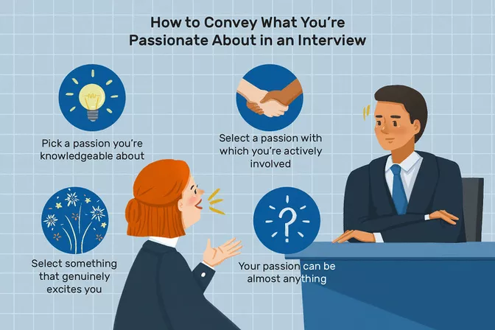

**Activity:10 How to answer what you’re passionate about**

**Objectives:**

**1.To make the students learn how to speak about their passion.**

**2.To make them involve in being able to be selective about their passion related to a specific kind.**

**Pre-Lab Questions:**

**1.Should you mention about your passion at an interview?If so why?**

**----------------------------------------------------------------------------------------------------------------------------------------------------------------------------------------------------------------------------------------------------------------------------------------------------------------------------------------------------------------------------------------------------------------------------------------------------**

**2.What kind of your passion is to be choosen?**

**---------------------------------------------------------------------------------------------------------------------------------------------------------------------------------------------------------------------------------------------------------------------------------------------------------------------------------------------------------------------------------------------------------------------------------------------------**

**What's the best way to answer "What are you passionate about?" at a job interview. How much information should you share? Is there anything you shouldn't mention? What does the hiring manager really want to know?**

**When you're asked what you are passionate about during a job interview, it's an excellent opportunity to tell the interviewer about your hobbies, enthusiasms, or whatever is important in your life. The hiring manager is looking to learn as much as possible about you and what you can bring to the company, in addition to the skills that qualify you for the job.**

**When answering interview questions about your interests, you should aim to demonstrate your commitment to your passion, whatever that might be.**

**You also want to be honest—interviewers can spot a canned answer instantly. Answer with honesty and just enough detail, and you will successfully show the hiring manager a bit more about who you are.**

**What the Employer Wants to Know**

**Why do companies want to know more about you than whether you meet the job requirements and are a good fit for the position?**

**Employers ask about your passions for a number of reasons. For example, they might ask about your favorite hobbies to find out about your personal interests and values. This question helps the employer work out whether you're a well-rounded person, with a life outside of the office.**

**The employer might also ask this question to get to know you on a personal level and to build a rapport.**

**Even if the hiring manager doesn't share your passion, he or she will relate to your enthusiasm.**

**By learning more about who you are as an individual, the employer can get a sense of whether you will fit in well with the company culture. While your passion does not have to be related to the work you will be doing at the company, your answer will show the hiring manager whether you are a committed person who follows through with what you believe in. This is an important quality for almost any job.**

**How to Answer “What Are You Passionate About?”**

**Before the interview, prepare by picking a passion that you will talk about if you get asked this question.**

**Select something that genuinely excites you. It doesn't have to be directly related to the job—in fact, it shouldn't be, because that will sound insincere (after all, who is really passionate about spreadsheets?).**

**The more sincere you are, the more likely the employer will be able to sense your genuine excitement.**

**You also want to pick a passion that you are knowledgeable about. The employer might ask you some follow-up questions, so you need to be comfortable talking about the topic for at least a few minutes. For example, if you say your passion is reading novels, the employer might ask what your favorite book is. If you say you love hiking, be ready to talk about some of your favorite places to hike. Be sure you know enough about the passion to provide some additional information.**

**Pick a passion that you are actively involved with in some way. For example, you might say your passion is playing guitar, and perhaps you can add that you play in a band. If you say your passion is working with children, perhaps you can mention a volunteer organization you work for. You want to show your ability to devote yourself to something you believe in, so you need to show how you follow through with your passion.**

**Keep in mind that your passion can involve almost anything. It can be a hobby you have, a cause you believe in, or even an abstract idea like competition or making a difference in other people's lives. Just make sure it's something you are genuiinely passionate about, something you know a bit about, and something you are actively engaged in.**

**Examples of the Best Answers**

**Review these sample answers to questions about your passion, with information on why the answer works well.**

**Example Answer**

**I lost my father to pancreatic cancer and, ever since then, I have spent time volunteering to help raise awareness and funds for cancer research. I volunteer for PanCan, an advocacy group, and I'm part of their volunteer network. One of the things I'm passionate about is helping to find a cure, in whatever way I can. I also love getting to know patients and survivors on a personal level.**

**Why It Works: This answer works well because it shows how the applicant took a personal tragedy and turned it into something positive.**

**Example Answer**

**I'm passionate about painting. I take an evening art class once a week and try to find time each weekend to paint. Painting is a good way for me to relax after a busy week. I also feel that it helps me to be more creative in other aspects of my life. Some of my most creative solutions to work problems have come when I'm painting in the studio.**

**Why It Works: Showing that you are able to take time away from work to relax shows that you’re a well-rounded candidate.**

**Example Answer**

**I'm passionate about baking. I love the process of researching new recipes and testing them out. I've been writing up my experiences with baking for the past three years, and every year, I host a massive cookie swap around holiday time with friends. I’m very detail-oriented, and love the scientific aspects of baking. However, I’m also a very social person, and use my baking as a chance to get together with friends and family.**

**Why It Works: The candidate shows both soft and hard skills—research and interpersonal skills—in this response.**

**Example Answer**

**Animals are my passion. I have two dogs and a cat, and I volunteer at my town’s pet adoption clinic every other weekend. I enjoy early morning walks and weekend hikes with my dogs. It helps me focus and gather my thoughts. I'm aware that your office has a dog-friendly policy, which I love!**

**Why It Works: The candidate shows her enthusiasm for her pets, which will be an asset in a pet-friendly workplace. This response also shows that the candidate has taken time to research the company.**

**Example Answer**

**My passion is working with students who are struggling academically. I tutor a group of first-graders once a week in reading and writing. I love helping students make connections in subjects they struggle with.**

**Why It Works: This response works well because the candidate is sharing a willingness to help others and to volunteer his or her time.**

**Tips for Giving the Best Answer**

**Be prepared for follow-up questions. The interviewer may ask follow-up questions about your passion, so make sure it's something you feel comfortable discussing. If film is your passion, for instance, interviewers may ask for movie recommendations, or inquire about your favorite movie.**

**Consider what kinds of follow-up questions you might get based on your passion, and be prepared to answer them.**

**Share examples. You might also get follow-up questions about what you do with your passion, or how you incorporate it into your life. Employers ask this to get a sense of how committed you are to things, and how good you are at seeing things through.**

**Provide some examples of how you have dedicated yourself to your interest or activity. When you share a story, it will support the details of what's important to you, and help you connect and engage with the interviewer.**

**You can also mention goals (such as training for a race, if running is your passion), which will give interviewers a sense of your long-term thinking and perseverance.**

**Explain why you are passionate. Along with explaining how you follow through with your passion in your daily life, it's good to also give a brief explanation as to why you love your particular hobby. Perhaps you love running because it gives you a chance to unwind, or it helps you think more creatively.**

**Maybe you love tutoring children because you enjoy helping students who are struggling to make connections. Explaining what you love about your passion will show you are sincere, and will give the employer a bit more insight into who you really are.**

**Connect it to the job naturally. It is fine (in fact, it's even preferable) if your passion does not directly connect with the job. However, you can often find natural ways to connect your hobby or interest to the position. For example, if your passion is working towards cancer research, and you are applying for a job in fundraising, you might mention how you volunteer for an organization and help them raise funds every year. If you are applying for a job in a bookstore and are passionate about reading novels, you might mention this.**

**Don't force a connection, but do try to find possible ways to relate your interests to the position if you can.**

**Be honest. While you want your answer to reveal your dedication and motivation, try to be genuine in your response. Don't make up a passion because you think it's what the employer wants to hear. Instead, mention a genuine passion. Your excitement will rub off on the employer, and show him or her that you are a broad-minded individual with interests outside of work.**

**What Not to Say**

**Don't overemphasize your passion. No matter what your answer is, be sure that what you share isn't something that could potentially cut into your working hours. For example, you don't want to say that you're a mountain climber with the goal of climbing Mountain Everest soon, or that you're looking forward to spending the entire winter skiing in Aspen. You don't want to appear so busy with your passion that you won't have time to get all your work done.**

**Don't share a passion that isn't workplace friendly. Everyone has different passions, but when you're sharing yours, be sure not to share anything that is controversial or inappropriate for the workplace.**

**Don't make something up. Share something you're really passionate about. For example, you don't want to say that your favorite activity is golf, if it's not, and then get invited to a golf outing where you won't have a clue how to play.**

**Post-Lab Questions:**

**1.What are your hobbies?**

**---------------------------------------------------------------------------------------------------------------------------------------------------------------------------------------------------------------------------------------------------------------------------------------------------------------------------------------**

**2.What motivates you?**

**---------------------------------------------------------------------------------------------------------------------------------------------------------------------------------------------------------------------------------------------------------------------------------------------------------------------------------------**

**3.How did you fit in with the company culture at your last job?**

**----------------------------------------------------------------------------------------------------------------------------------------------------------------------------------------------------------------------------------------------------------------------------------------------------------------------------------------------------------------------------------------------------------------------------------------------------**

**4.Why do you want this job?**

**----------------------------------------------------------------------------------------------------------------------------------------------------------------------------------------------------------------------------------------------------------------------------------------------------------------------------------------------------------------------------------------------------------------------------------------------------**

**5.Discuss about your passion?**

**------------------------------------------------------------------------------------------------------------------------------------------------------------------------------------------------------------------------------------------------------------------------------------------------------------------------------------------------------------------------------------------------------------------------------------------------------------------------------------------------------------------------------------------------------------------------------------------------------------------------------------------------------------------------------**

**Key Takeaways**

**BE HONEST:**

**When you respond to the question, share something that you truly care about.**

**PREPARE A RESPONSE:**

**It’s easier to respond when you have an idea of what you are going to say.**

**BE ENTHUSIASTIC.**

**Remember, this is passion that you’re talking about. Be sure that your enthusiasm and positivity are clear when you answer.**

**Outcomes:**

**By the end of this session,students will be able to learn**

**1.How to answer about their passions precisely.**

**2.They are made to remember and memorise what not to say.**

|  |  |  |  |  |  |  |
| --- | --- | --- | --- | --- | --- | --- |
| **Date of submission** |  |  |  |  |  |  |
| **Name of the Evaluator** |  |  |  |  |  |  |
| **Marks**  **Awarded** | **Pre lab questions**  **(2M)** | **Format and structure**  **(2M)** | **Content**  **(2M)** | **Language and Tone**  **(2M)** | **Post Lab Questions**  **(2M)** | **Total**  **(10M)** |
|  |  |  |  |  |  |
| **Remarks** |  |  |  |  |  |  |
| **Signature of the Evaluator with Date** |  |  |  |  |  |  |

**How to Answer "Why Are You the Best Person for the Job?"**

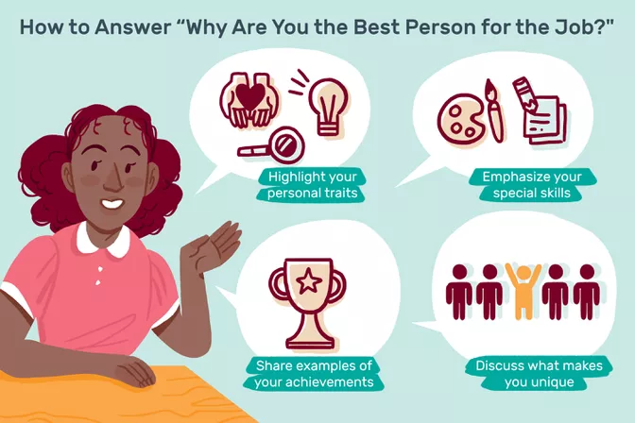

**Activity:11**

**Objectivies:**

**1.To make the students learn how to answer “Why he/she is the best person for that particular job.**

**2.To eqquip them with stuff,where they are able to answer “Why they should be hired?**

**Pre-Lab Questions:**

**1.Do you think the HR might ask you,why he/She needs to hire you for their MNC?If so why?**

**-----------------------------------------------------------------------------------------------------------------------------------------------------------------------------------------------------------------------------------------------------------------------------------------------------------------------------------------------------------------------------------------------------------------------------------------------------------------------------------------------------------------------------------------------------------------**

**2.What would be your response to that particular question?**

**----------------------------------------------------------------------------------------------------------------------------------------------------------------------------------------------------------------------------------------------------------------------------------------------------------------------------------------------------------------------------------------------------------------------------------------------------**

**During a job interview, the interviewer might ask you the question, “Why are you the best person for the job?” This is similar to other common interview questions, such as “Why should we hire you?” The interviewer wants to know why you would be a better option to hire than other candidates.**

**What the Interviewer Wants to Know**

**The interviewer also want to make sure you know what they are looking for in a job candidate, and that you have the ability to do the job if you were to be hired. One of the goals of the interview is to determine whether you are a good fit for both the role and the organization. On the flip side, you'll also need to decide if the job is a good match for what you're looking for in your next role.**

**When answering this kind of question, your objective is to sell yourself to the hiring manager and convince them that you are a unique and strong candidate. Read below for advice on preparing for and answering this interview question, as well as examples of the best responses.**

**How to Answer "Why Are You the Best Person for the Job?"**

**There are many ways you can answer this question. The first way is to explain how your personality or personal traits make you an ideal candidate. To do that, take the time before the interview to carefully match your qualifications to those listed in the job posting. Be prepared to explain why you're a solid match for the job.**

**For example, you might explain that you are particularly motivated, or that you are known for going above and beyond for your employers.**

**A second way to answer is to emphasize your unique skills. If you have skills that make you a strong candidate (especially if not many people have those skills), mention these. The skills the employer is seeking may also be listed in the job posting. If not, look at similar jobs to see what criteria employers are looking for.**

**Another option is to show the employer that what you have accomplished in your previous roles qualify you for this one. Share examples of your achievements that relate to the job for which you're interviewing.**

**Example Answer #1**

**My previous job working as a receptionist provided me with the ideal experience for this position. For five years, I developed many of the skills required for this job, including answering phones and email, processing payments, and entering data on multiple computer programs.**

**Why It Works: This response is effective because the candidate goes into specifics in listing the essential skill set she can bring to her new employer. Ideally, she has also emphasized these skills because she realized from reading the job posting that these talents were among the employer’s most “preferred qualifications.”**

**Example Answer #2**

**My skill set is a perfect match for the job requirements. In particular, my sales skills and managerial experience make me an ideal candidate for the position. For example, at my last job, I managed a sales team of five employees, and we had the top sales record of our company branch. I can bring my successes and experiences to this job.**

**Why It Works: Not only does this interviewee mention his important skills, but he also alludes to his previous leadership responsibilities and his quantifiable success (a “top sales record”) in his previous work.**

**Tips for Giving the Best Response**

**Prepare in advance. Before an interview, think carefully about what makes you an ideal candidate for the position. First, look at the job listing, and circle any key skills or qualifications. Then, look at your resume and note any particular experiences or skills that fit the job listing. Emphasize those qualifications in your answer to the question.**

**Share examples. It's important to be as specific as possible when answering this question. Whether you emphasize your skills or a personality trait, be sure to provide one or two specific examples that prove you have those qualities and how you will use them in the workplace.**

**Ideally, your examples will come from past experiences at work. If you’re new to the job market, you can also emphasize experiences from school, extracurricular activities, or volunteer work.**

**Focus on how you can help the company. Avoid answers that emphasize why you want the job. Instead, focus on how you can add value to the company. To prepare for this kind of answer, make sure you have some knowledge about the company ahead of time. Take the time to review the company's website, social media pages, and other information about the organization that's available online.**

**Don’t compare yourself to others. Even though the question is about how you compare to other candidates, don’t critique the other job seekers. This can come across as negative or rude.**

**Instead, emphasize what makes you unique in a positive manner, without attacking or insulting other candidates. It's important to sell your qualifications without being considered arrogant or overbearing.**

**Don’t say this: "Unlike some of the other candidates I’m sure you’ve seen today, I have experience in the field, which means that I can hit the ground running on day one."**

**Do say: "My years of experience in this field have given me on-the-job knowledge, as well as a sense of where the industry has been and where it’s going in the future. I have the kind of technical skills that only come from doing the job for several years. I can slide seamlessly into this role and start hitting goals on my very first day."**

**RESEARCH THE COMPANY:**

**Before your interview, write down a list of how your work skills match up with the “preferred” qualifications mentioned on the job posting. Then, in your answer, make sure you talk about these key skills, using examples when possible, to prove that you are the best person for the job.**

**BEWARE COMPARISONS:**

**While it’s smart to highlight the skills that you believe set you apart from other candidates for the position, don’t throw shade on others. Keep your tone positive, and talk about what you yourself can offer the company rather than upon what they cannot.**

**FOCUS ON THE EMPLOYER’S NEEDS:**

**In your answer, describe all of your hard and soft skills that would “add value” should the employer hire you. Don’t make your response about you (i.e., a plea as to why you really want the job.**

**Post-Lab Questions:**

**1.Why did you leave your previous job?**

**----------------------------------------------------------------------------------------------------------------------------------------------------------------------------------------------------------------------------------------------------------------------------------------------------------------------------------------------------------------------------------------------------------------------------------------------------**

**2.What are your salary expectations?**

**----------------------------------------------------------------------------------------------------------------------------------------------------------------------------------------------------------------------------------------------------------------------------------------------------------------------------------------------------------------------------------------------------------------------------------------------------**

**3.Why do you want this job?**

**-----------------------------------------------------------------------------------------------------------------------------------------------------------------------------------------------------------------------------------------------------------------------------------------------------------------------------------------------------------------------------------------------------------------------------------------------------------------------------------------------------------------------------------------------------------------**

**4.Why are you the best person for this particular job and what are the traits that make you unique from the others?**

**----------------------------------------------------------------------------------------------------------------------------------------------------------------------------------------------------------------------------------------------------------------------------------------------------------------------------------------------------------------------------------------------------------------------------------------------------------------------------------------------------------------------------------------------------------------------------------------------------------------------------------------------------------------------------------------------------------------------------------------------------------------------------------------------------------------------------------------------------------------------------------------------------------------------------------------------------------------------------------------------------------------------------------------------------------------------------------------------------------------------------------**

**Outcomes:**

**After this session,students will be able to answer**

**1.All the possible questions related to the HR round.**

**2.Students learn/imbibe a lot of stuff and have an overall idea of what kind of questions will be posed by the HR’s at the time of their interviews.**

|  |  |  |  |  |
| --- | --- | --- | --- | --- |
| **Date of submission** |  |  |  |  |
| **Name of the Evaluator** |  |  |  |  |
| **Marks awarded**  **(Max.Marks-10M)** | **Pre –Lab Questions**  **(2M)** | **Activity**  **(6M)** | **Post-Lab Questions**  **(2M)** | **Total**  **(10M)** |
|  |  |  |  |
| **Remarks** |  |  |  |  |
| **Signature of the Evaluator with Date** |  |  |  |  |